Мирзаитов Тимур Курсовая работа часть №2 Вариант 75

C=(A+1) mod25

Где А= (а1, а2, а3, а4, а5), С= (С0, С1, С2, С3, С4)

# Составлениетаблицы истинности

|  |  |  |  |  |  |  |  |  |  |
| --- | --- | --- | --- | --- | --- | --- | --- | --- | --- |
| a1 | a2 | a3 | a4 | a5 | c0 | c1 | c2 | c3 | c4 |
| 0 | 0 | 0 | 0 | 0 | 0 | 0 | 0 | 0 | 1 |
| 0 | 0 | 0 | 0 | 1 | 0 | 0 | 0 | 1 | 0 |
| 0 | 0 | 0 | 1 | 0 | 0 | 0 | 0 | 1 | 1 |
| 0 | 0 | 0 | 1 | 1 | 0 | 0 | 1 | 0 | 0 |
| 0 | 0 | 1 | 0 | 0 | 0 | 0 | 1 | 0 | 1 |
| 0 | 0 | 1 | 0 | 1 | 0 | 0 | 1 | 1 | 0 |
| 0 | 0 | 1 | 1 | 0 | 0 | 0 | 1 | 1 | 1 |
| 0 | 0 | 1 | 1 | 1 | 0 | 1 | 0 | 0 | 0 |
| 0 | 1 | 0 | 0 | 0 | 0 | 1 | 0 | 0 | 1 |
| 0 | 1 | 0 | 0 | 1 | 0 | 1 | 0 | 1 | 0 |
| 0 | 1 | 0 | 1 | 0 | 0 | 1 | 0 | 1 | 1 |
| 0 | 1 | 0 | 1 | 1 | 0 | 1 | 1 | 0 | 0 |
| 0 | 1 | 1 | 0 | 0 | 0 | 1 | 1 | 0 | 1 |
| 0 | 1 | 1 | 0 | 1 | 0 | 1 | 1 | 1 | 0 |
| 0 | 1 | 1 | 1 | 0 | 0 | 1 | 1 | 1 | 1 |
| 0 | 1 | 1 | 1 | 1 | 1 | 0 | 0 | 0 | 0 |
| 1 | 0 | 0 | 0 | 0 | 1 | 0 | 0 | 0 | 1 |
| 1 | 0 | 0 | 0 | 1 | 1 | 0 | 0 | 1 | 0 |
| 1 | 0 | 0 | 1 | 0 | 1 | 0 | 0 | 1 | 1 |
| 1 | 0 | 0 | 1 | 1 | 1 | 0 | 1 | 0 | 0 |
| 1 | 0 | 1 | 0 | 0 | 1 | 0 | 1 | 0 | 1 |
| 1 | 0 | 1 | 0 | 1 | 1 | 0 | 1 | 1 | 0 |
| 1 | 0 | 1 | 1 | 0 | 1 | 0 | 1 | 1 | 1 |
| 1 | 0 | 1 | 1 | 1 | 1 | 1 | 0 | 0 | 0 |
| 1 | 1 | 0 | 0 | 0 | 0 | 0 | 0 | 0 | 0 |
| 1 | 1 | 0 | 0 | 1 | 0 | 0 | 0 | 0 | 1 |
| 1 | 1 | 0 | 1 | 0 | 0 | 0 | 0 | 1 | 0 |
| 1 | 1 | 0 | 1 | 1 | 0 | 0 | 0 | 1 | 1 |
| 1 | 1 | 1 | 0 | 0 | 0 | 0 | 1 | 0 | 0 |
| 1 | 1 | 1 | 0 | 1 | 0 | 0 | 1 | 0 | 1 |
| 1 | 1 | 1 | 1 | 0 | 0 | 0 | 1 | 1 | 0 |
| 1 | 1 | 1 | 1 | 1 | 0 | 0 | 1 | 1 | 1 |

# Минимизация булевых функций системы

|  |  |  |  |  |  |  |  |  |  |  |  |  |
| --- | --- | --- | --- | --- | --- | --- | --- | --- | --- | --- | --- | --- |
|  | a1a2 |  |  |  |  |  |  | a1a2 |  |  |  |  |
| a3a4 |  | 00 | 01 | 11 | 10 |  | a3a4 |  | 00 | 01 | 11 | 10 |
|  | 00 |  |  |  | 1 |  |  | 00 |  |  |  | 1 |
|  | 01 |  |  |  | 1 |  |  | 01 |  |  |  | 1 |
|  | 11 |  |  |  | 1 |  |  | 11 |  | 1 |  | 1 |
|  | 10 |  |  |  | 1 |  |  | 10 |  |  |  | 1 |
|  |  |  |  |  |  |  |  |  |  |  |  |  |
|  |  | a5=0 |  |  |  |  |  |  | a5=1 |  |  |  |

|  |  |  |  |  |  |  |  |  |  |  |  |
| --- | --- | --- | --- | --- | --- | --- | --- | --- | --- | --- | --- |
|  | a1a2 |  |  |  |  |  | a1a2 |  |  |  |  |
| a3a4 |  | 00 | 01 | 11 | 10 | a3a4 |  | 00 | 01 | 11 | 10 |
|  | 00 |  | 1 |  |  |  | 00 |  | 1 |  |  |
|  | 01 |  | 1 |  |  |  | 01 |  | 1 |  |  |
|  | 11 |  | 1 |  |  |  | 11 | 1 |  |  | 1 |
|  | 10 |  | 1 |  |  |  | 10 |  | 1 |  |  |
|  |  |  |  |  |  |  |  |  |  |  |  |
|  |  | a5=0 |  |  |  |  |  | a5=1 |  |  |  |

|  |  |  |  |  |  |  |  |  |  |  |  |
| --- | --- | --- | --- | --- | --- | --- | --- | --- | --- | --- | --- |
|  | a1a2 |  |  |  |  |  | a1a2 |  |  |  |  |
| a3a4 |  | 00 | 01 | 11 | 10 | a3a4 |  | 00 | 01 | 11 | 10 |
|  | 00 |  |  |  |  |  | 00 |  |  |  |  |
|  | 01 |  |  |  |  |  | 01 | 1 | 1 | 1 | 1 |
|  | 11 | 1 | 1 | 1 | 1 |  | 11 |  |  |  |  |
|  | 10 | 1 | 1 | 1 | 1 |  | 10 | 1 | 1 | 1 | 1 |
|  |  |  |  |  |  |  |  |  |  |  |  |
|  |  | a5=0 |  |  |  |  |  | a5=1 |  |  |  |

|  |  |  |  |  |  |  |  |  |  |  |  |
| --- | --- | --- | --- | --- | --- | --- | --- | --- | --- | --- | --- |
|  | a1a2 |  |  |  |  |  | a1a2 |  |  |  |  |
| a3a4 |  | 00 | 01 | 11 | 10 | a3a4 |  | 00 | 01 | 11 | 10 |
|  | 00 |  |  |  |  |  | 00 | 1 | 1 |  | 1 |
|  | 01 | 1 | 1 | 1 | 1 |  | 01 |  |  | 1 |  |
|  | 11 | 1 | 1 | 1 | 1 |  | 11 |  |  | 1 |  |
|  | 10 |  |  |  |  |  | 10 | 1 | 1 |  | 1 |
|  |  |  |  |  |  |  |  |  |  |  |  |
|  |  | a5=0 |  |  |  |  |  | a5=1 |  |  |  |

|  |  |  |  |  |  |  |  |  |  |  |  |
| --- | --- | --- | --- | --- | --- | --- | --- | --- | --- | --- | --- |
|  | a1a2 |  |  |  |  |  | a1a2 |  |  |  |  |
| a3a4 |  | 00 | 01 | 11 | 10 | a3a4 |  | 00 | 01 | 11 | 10 |
|  | 00 | 1 | 1 |  | 1 |  | 00 |  |  | 1 |  |
|  | 01 | 1 | 1 |  | 1 |  | 01 |  |  | 1 |  |
|  | 11 | 1 | 1 |  | 1 |  | 11 |  |  | 1 |  |
|  | 10 | 1 | 1 |  | 1 |  | 10 |  |  | 1 |  |
|  |  |  |  |  |  |  |  |  |  |  |  |
|  |  | a5=0 |  |  |  |  |  | a5=1 |  |  |  |

$$C_{min}\left(C_{4}\right)=\left\{\begin{matrix}0XXX0 \\ X0XX0 \\ 11XX1\end{matrix}\right\}, S^{a}= 7, S^{b}=10$$

$$C_{4}= \overline{a_{1}}\overline{a_{5}}∨ \overline{a_{2}}\overline{a_{5}}∨a_{1}a_{2}a_{5}$$

$\left\{\begin{matrix}C_{0}= a_{1}\overline{a_{2} }∨ \overline{a_{1}}a_{2}a_{3}a_{4}a_{5} \\ C_{1}= \overline{a_{1}}a_{2}\overline{a_{5}} ∨ \overline{a_{1}}a_{2}\overline{a_{3}} ∨ \overline{a_{1}}a_{2}a_{3}\overline{a_{4}} ∨ a_{1}\overline{a_{2}}a_{3}a_{4}a_{5} \\ \begin{matrix}C_{2}= a_{3}\overline{a_{5}} ∨ a_{3}\overline{a_{4}} ∨ \overline{a_{3}}a_{4}a_{5} \\ C_{3}= a_{4}\overline{a_{5}}∨ a_{1}a_{2}a_{4}∨\overline{a_{2}}\overline{a_{4}}a_{5}∨\overline{a_{1}}\overline{a_{4}}a_{5} \\ C_{4}= \overline{a_{1}}\overline{a_{5}}∨ \overline{a_{2}}\overline{a_{5}}∨a_{1}a_{2}a_{5}\end{matrix}\end{matrix}\right.$ $\begin{matrix}(S_{Q}^{C0}= 9) \\ (S_{Q}^{C1}= 19) \\ \begin{matrix}(S_{Q}^{C2}= 10) \\ (S_{Q}^{C3}= 15) \\ (S_{Q}^{C4}= 10)\end{matrix}\end{matrix}$

# Преобразование минимальных форм булевых функций системы

$$\left\{\begin{matrix}C_{0}= a_{1}\overline{a_{2} }∨ \overline{a_{1}}a_{2}a_{3}a_{4}a_{5} \\ C_{1}= \overline{a_{1}}a_{2}\overline{a_{5}} ∨ \overline{a_{1}}a_{2}\overline{a_{3}} ∨ \overline{a_{1}}a_{2}a_{3}\overline{a_{4}} ∨ a_{1}\overline{a_{2}}a_{3}a_{4}a_{5}= \overline{a_{1}}a_{2}\overline{(a_{3}a_{5})}∨ a_{1}\overline{a_{2}}a_{3}a_{4}a_{5} \\ \begin{matrix}C_{2}= a_{3}\overline{a_{5}} ∨ a_{3}\overline{a_{4}} ∨ \overline{a_{3}}a_{4}a_{5}=a_{3}\left(\overline{a_{4}}∨\overline{a_{5}}\right)∨ \overline{a_{3}}a_{4}a_{5} \\ C_{3}= a_{4}\overline{a_{5}}∨ a_{1}a_{2}a_{4}∨\overline{a_{2}}\overline{a_{4}}a_{5}∨\overline{a_{1}}\overline{a_{4}}a_{5}= a_{4}(\overline{a_{5}}∨a_{1}a_{2})∨\overline{a_{4}}a_{5}(\overline{a_{1}}∨\overline{a_{2}}) \\ C_{4}= \overline{a_{1}}\overline{a_{5}}∨ \overline{a_{2}}\overline{a_{5}}∨a_{1}a_{2}a_{5}= \overline{a_{5}}(\overline{a_{1}}∨\overline{a_{2}})∨a_{1}a_{2}a_{5}\end{matrix}\end{matrix}\right.\begin{matrix}(S_{Q}^{C0}= 9) \\ (S_{Q}^{C1}= 12) \\ \begin{matrix}(S_{Q}^{C2}= 10) \\ (S_{Q}^{C3}= 14) \\ (S_{Q}^{C4}= 10)\end{matrix}\end{matrix}$$

$$\left\{\begin{matrix}\begin{matrix}z_{1}=\overline{a_{1}}a_{2} \\ z_{2}= a_{4}a_{5} \\ z_{3}=a_{1}a_{2}\end{matrix} \\ \begin{matrix}C_{0}= a_{1}\overline{a_{2} }∨ {z_{1}a}_{3}z_{2} \\ C_{1}= z_{1}\overline{(a_{3}a_{5})}∨ a_{1}\overline{a_{2}}a_{3}z_{2} \\ \begin{matrix}C_{2}=a_{3}\overline{z_{2}}∨ \overline{a_{3}}z_{2} \\ C_{3}= a_{4}(\overline{a_{5}}∨z_{3})∨\overline{a_{4}}a_{5}\overline{z_{3}} \\ C_{4}=\overline{a_{5}}\overline{z_{3}}∨z_{3}a_{5}=(\overline{z_{3}}∨a_{5})(z_{3}∨\overline{a_{5}})\end{matrix}\end{matrix}\end{matrix}\right.\begin{matrix}\begin{matrix}{(S}_{Q}^{z1}=2) \\ {(S}_{Q}^{z2}=2) \\ (S_{Q}^{z3}=2)\end{matrix} \\ \begin{matrix}(S_{Q}^{C0}= 7) \\ (S_{Q}^{C1}= 8) \\ \begin{matrix}(S_{Q}^{C2}= 16) \\ (S_{Q}^{C3}= 10) \\ (S_{Q}^{C4}= 6)\end{matrix}\end{matrix}\end{matrix}$$

$$\left\{\begin{matrix}z_{1}=\overline{a_{1}}a_{2} \\ z_{2}= a_{4}a_{5} \\ \begin{matrix}z_{3}=a_{1}a_{2} \\ \begin{matrix}z_{4}=\overline{z_{3}}a_{5} \\ z_{5}=\overline{a_{2}}a_{5}\end{matrix} \\ \begin{matrix}C_{0}= z_{5}∨ {z_{1}a}_{3}z_{2} \\ C_{1}= z_{1}\overline{(a_{3}a_{5})}∨ z_{5}a_{3}z_{2} \\ \begin{matrix}C_{2}=a_{3}\overline{z_{2}}∨ \overline{a_{3}}z_{2} \\ C_{3}= a_{4}\overline{z_{4}}∨\overline{a_{4}}z_{4} \\ C_{4}=(\overline{z_{3}}∨a_{5})\overline{z_{4}}\end{matrix}\end{matrix}\end{matrix}\end{matrix}\right.\begin{matrix}{(S}_{Q}^{z1}=2) \\ {(S}_{Q}^{z2}=2) \\ \begin{matrix}{(S}_{Q}^{z3}=2) \\ \begin{matrix}{(S}_{Q}^{z4}=2) \\ {(S}_{Q}^{z5}=2)\end{matrix} \\ \begin{matrix}(S_{Q}^{C0}= 6) \\ (S_{Q}^{C1}= 8) \\ \begin{matrix}(S_{Q}^{C2}= 16) \\ (S_{Q}^{C3}= 6) \\ (S_{Q}^{C4}= 4)\end{matrix}\end{matrix}\end{matrix}\end{matrix}$$

# Синтез многовыходной комбинационной схемы в булевом базисе

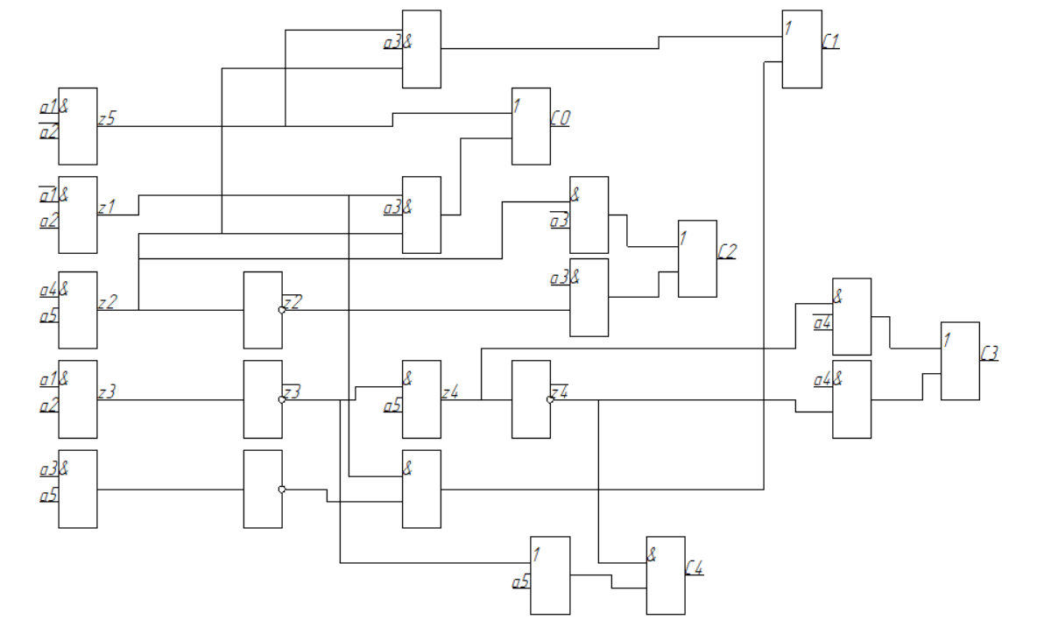

# Анализ многовыходной комбинационной схемы

На рисунке показано определение реакции схемы на входной набор (01000). Значение выходного набора (01001) соответствует таблице истинности, что подтверждает корректность построенной схемы, по крайней мере, в отношении рассматриваемого набора.

